GLOBAL SYSTEMS
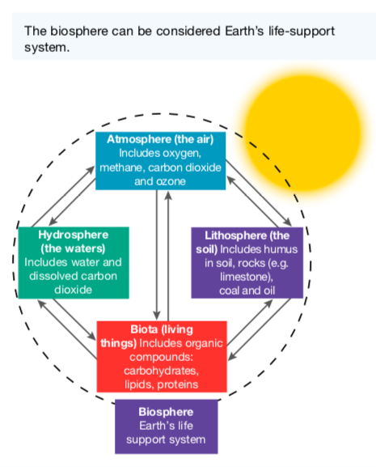
Biosphere

The biosphere consists of the atmosphere, lithosphere, hydrosphere and biota (living things), the interactions between them, and the radiant energy of the sun.

The biosphere includes all of the ecosystems on Earth. Interactions within the biosphere include the cyclical movement of essential elements such as carbon, nitrogen and phosphorus.

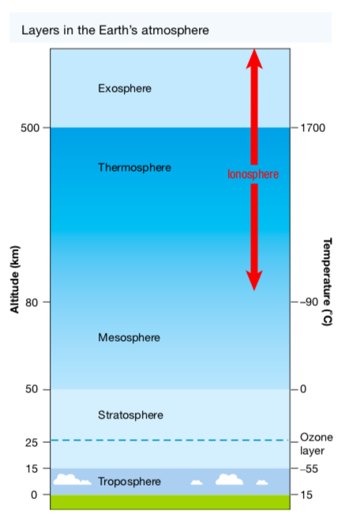
Atmosphere

The Earth’s atmosphere is divided into the troposphere (lower atmosphere) and the stratosphere (upper atmosphere).

The troposphere is around 6-17 km high depending on your latitude (how close you are to Earth’s equator or the poles).

The stratosphere is about 50 km thick and contains an area known as the ozone layer. While this layer allows visible and infra-red radiation from the sun through, it absorbs ultraviolet (UV) radiation. This reduces the amount of damaging UV radiation reaching Earth’s surface.

Chlorofluorocarbons (CFCs) have been used as cooling agents in refrigerators and air conditioners, as propellants in aerosols, and as industrial solvents.

Their use has increased the amount of these com- pounds being released into the atmosphere. Once in the stratosphere, they are broken down into chlorine atoms, which destroy ozone molecules. This has depleted areas of the ozone layer, increasing the amount of damaging UV rays that get through and cause damage to living organisms.
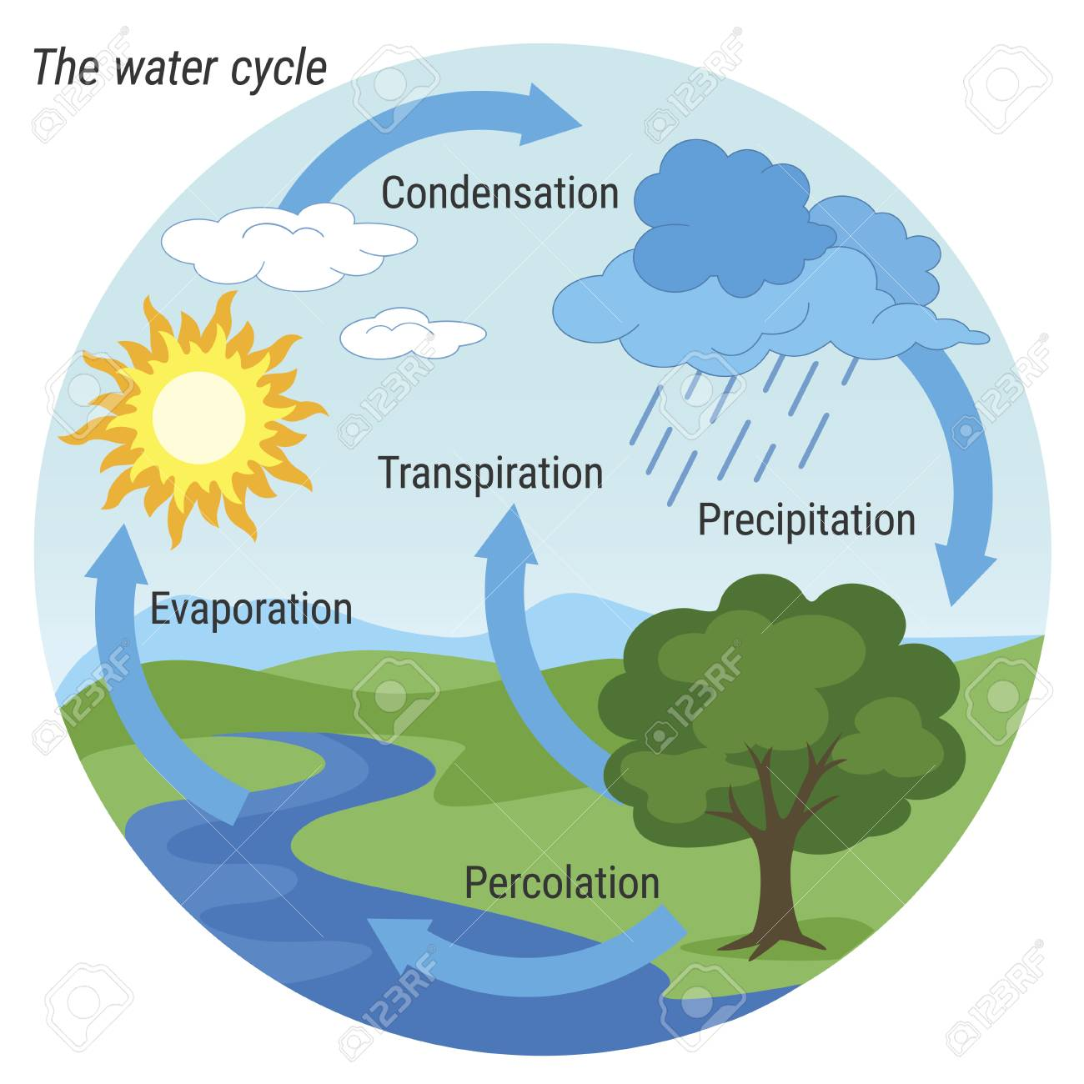
Hydrosphere

The waters of our planet make up the hydrosphere. The simplified figure of the water cycle shown at right describes how water moves through the biosphere.

Toxic or industrial wastes and untreated sewage have made their way into rivers, bays and the ocean, which has had a direct impact on the hydrosphere. Toxins can move along food chains, in some cases being biologically magnified - getting more concentrated - as they move up the chain.

While some of these wastes are purposefully dumped, in other cases they enter the water system in run-off from the land or are washed out of the atmosphere in rain.

Geosphere (Lithosphere)

Earth’s rocky crust and soil make up the lithosphere. It is within this sphere that igneous, sedimentary and metamorphic rocks are formed, broken down and changed from one type to another.
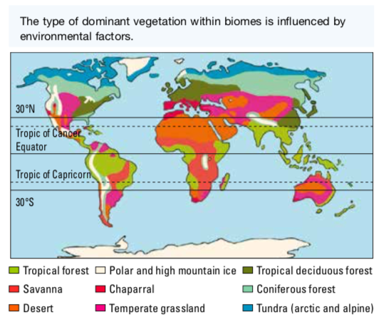
The land surface of our planet is divided into regions called biomes. The criterion used to divide regions into biomes is the dominant vegetation type.

Environmental factors (such as latitude, temperature and rainfall) influence the type of vegetation that can survive in a particular area and so can be used to predict the type of biome that may exist there.

Overstocking, soil exhaustion, salinity, pesticides, unstable landfill, salinisation, toxic seepage, excessive clearing, chemical emissions, deforestation and soil erosion can all be very destructive to the lithosphere. Overgrazing and deforestation may also result in desertification. They can have detrimental effects on habitats and resources and hence the survival of organisms within the ecosystem.

